1. Guess the logo



2. **Question:** A person is getting ready to leave and needs a pair of matching socks. If there are n colors of socks in the drawer, how many socks need to be removed to be certain of having a matching pair?

a) n+1

b) 2n

c) n

d) n^2

SOLUTION: n+1

3. On the eve of Diwali, Shubham is decorating his house with a serial light bulb set. The set has N bulbs placed sequentially on a string, which is programmed to change patterns every second. If at least one bulb in the set is on at any given instant of time, how many different patterns of light can the serial light bulb set produce?

**Options:**

a) 2^N

b) 2^N+1−2

c) 2^{N}- 1

d) 2^N+1 + 2

c)

Question:

Which of the following AI products is specifically designed to simulate human-like conversations in real-time, tailored for customer service and interactive applications?

a) Rasa

b) Keras

c) PyCaret

d) DALL·E

a Rasa

UCEED Questions

2017

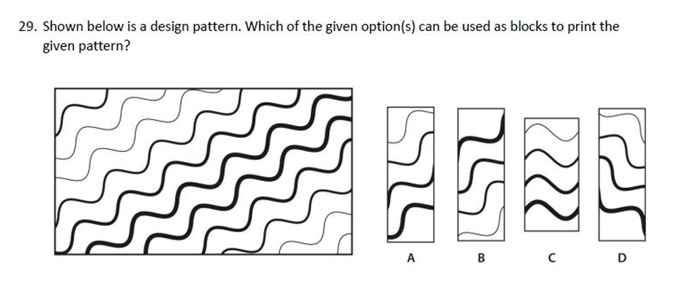

All of the above

2018

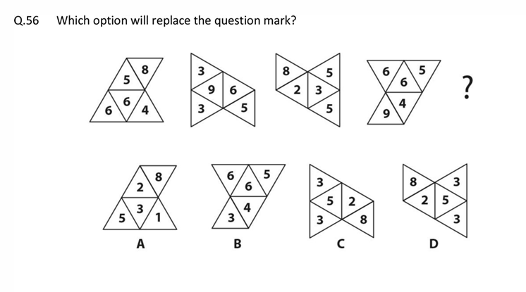

ANS: B

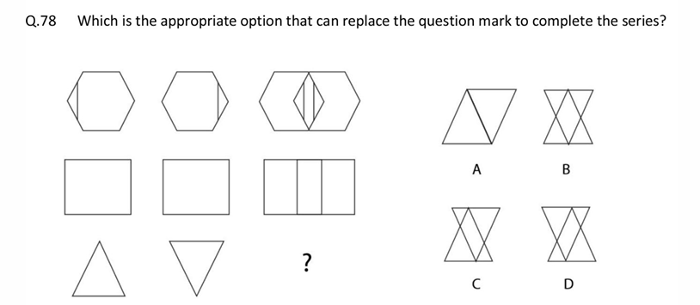

ANS: C or D

2019

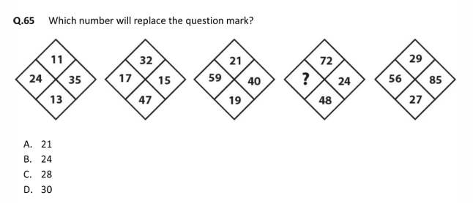

B) 24

2021

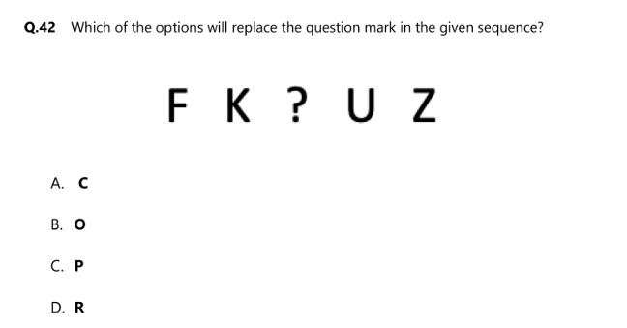

c. P

2015

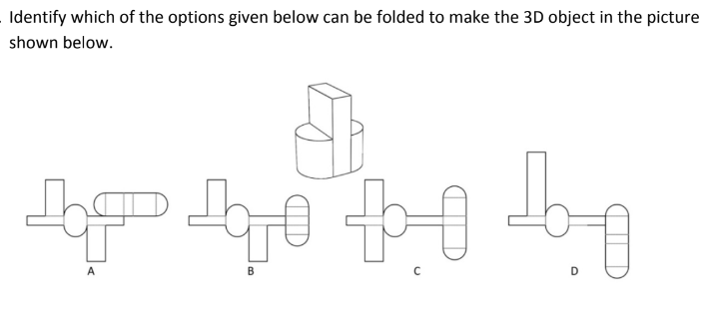

A or C

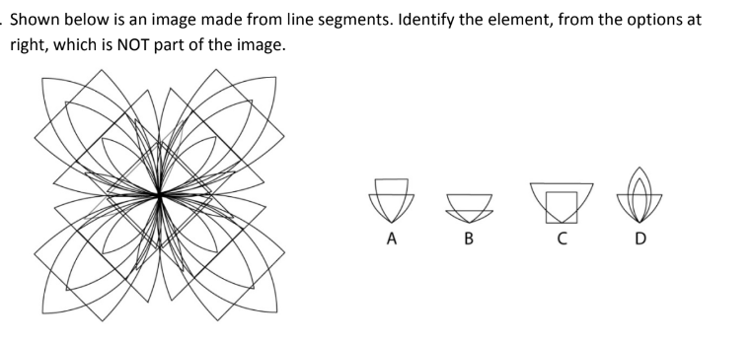

C

Python

Write the output for the following code

a = {i**3*1j: i * i for i in range(6)}

print(a)

1. {0j: 0, 1j: 1, 4j: 4, 9j: 9, 16j: 16, 25j: 25}
2. {0j: 0, 1j: 1, 8j: 4, 27j: 9, 64j: 16, 125j: 25}
3. NameError: name '1j' is not defined
4. SyntaxError: cannot assign to literal here

Write the output for the following code

print(0.1 + 0.2 == 0.3)

1. True
2. False
3. Machine dependent
4. Error

What does ~~~~~5 // 3 evaluate to?

1. 1
2. -2
3. 2
4. -1